**Exercise**

# Problem: 1 | Arrays 1 dimensional

Write a program to declare an integer array of size 15. Now input some values in all indexes of array without using any loop. Finally display value at index 2.

# Problem: 2 | Arrays 1 dimensional

Write a program to initialize array of size 10 in single statement. Then find there sum and print numbers in reverse order.

# Problem: 3 | Arrays 1 dimensional, Random Numbers

Write a program to initialize 200 random numbers using array. Display all numbers with proper spaces and line break after 10 numbers.

# Problem: 4 | Arrays 1 dimensional

Suppose list is an array of six components of type int. What is stored in list after the following C++ code executes?

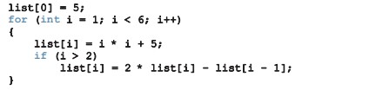

**Problem: 5 | Array 1 dimensional**

1. Determine whether the following array declarations are valid

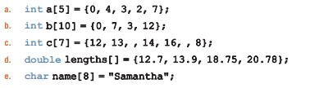

1. Suppose that you have the following declaration:



# Problem: 6 | Array 1 dimensional

Write a C++ program that declares an array alpha of 60 components of type double. Initialize the array so that the first 20 components are equal to the square of the index variable, and the next 20 components are equal to three times the index variable. Last 20 elements are the sum of first 20 and last 20 indices. Output the array so that 10 elements per line are printed.

# Problem: 7 | Array 1 dimensional, Searching

Write a C++ program to find an element from an array. Each element will be checked. If searched element exists multiple time, then its count will also be shown. Also show a message to user to update the word if found using input.

# Problem: 8 | Array 1 dimensional, Duplicate Elimination

Use a one-dimensional array to solve the following problem. Read in 25 numbers, each of which is between 10 and 100, inclusive. As each number is read, validate it and store it in the array only if it isn’t a duplicate of a number already read. After reading all the values, display only the unique values that the user entered. Provide for the “worst case” in which all 25 numbers are different. Use the smallest possible array to solve this problem.

# Problem: 9 | Shifting Array

Write a program that will be given as input an array and an integer p. The program will then cyclically shift the array p positions to the right: each element is moved p positions to the right, while the last p elements are moved to the beginning of the array. For example: if we have the array [1 2 3 4 5 6], shifting 2 positions to the right should give the array [5 6 1 2 3 4]. Your function should work correctly for negative values of p.

# Problem: 10 | Dice rolling

Write a program that simulates the rolling of two dice. The program should use rand to roll the first die and should use rand again to roll the second die. The sum of the two values should then be calculated. [*Note:* Each die can show an integer value from 1 to 6, so the sum of the two values will vary from 2 to 12, with 7 being the most frequent sum and 2 and 12 being the least frequent sums.] Figure shows the 36 possible combinations of the two dice. Your program should roll the two dice 1,000 times. Use a one-dimensional array to tally the numbers of times each possible sum appears. Print the result count.

